OSSP – Open-Source Sea-ice Processing

LABELING GUIDE

1. Check conda installation

Conda is a tool for managing and deploying applications, environments, and packages

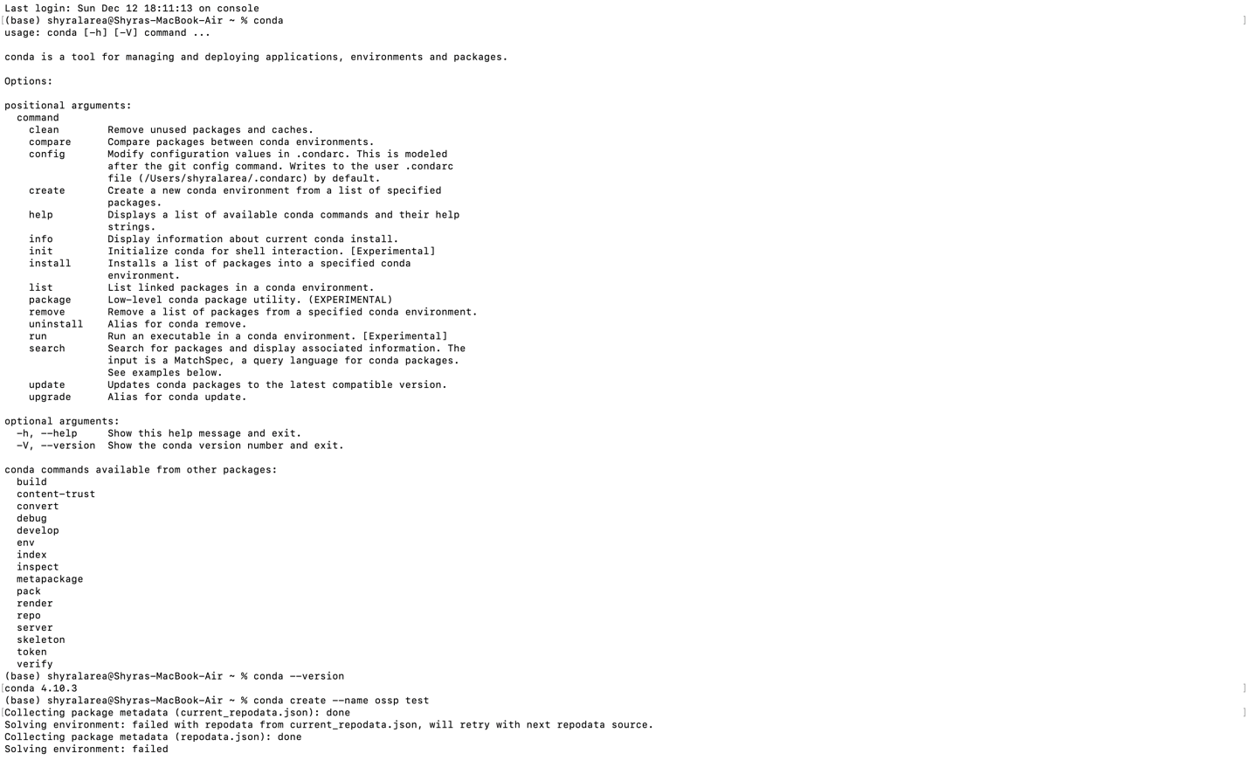

Check the conda version use: conda -- version

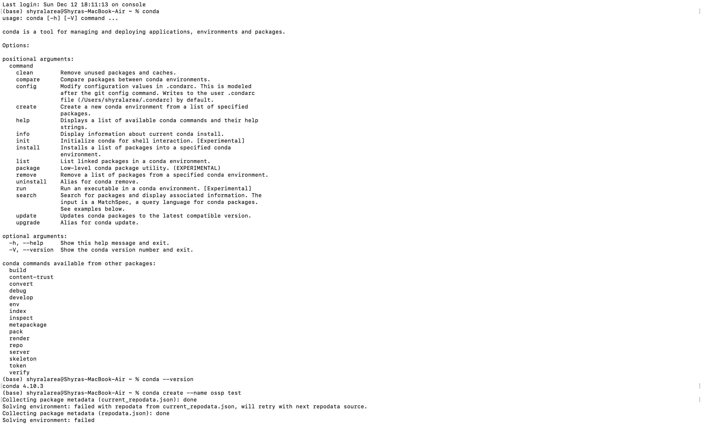

Latest version/ Applicable version: conda 4.10.3

https://www.anaconda.com/products/individual

1. An environment must be set up.

Using a conda virtual environment makes installing package dependencies a smoother process.

To create a conda environment use the following commands:

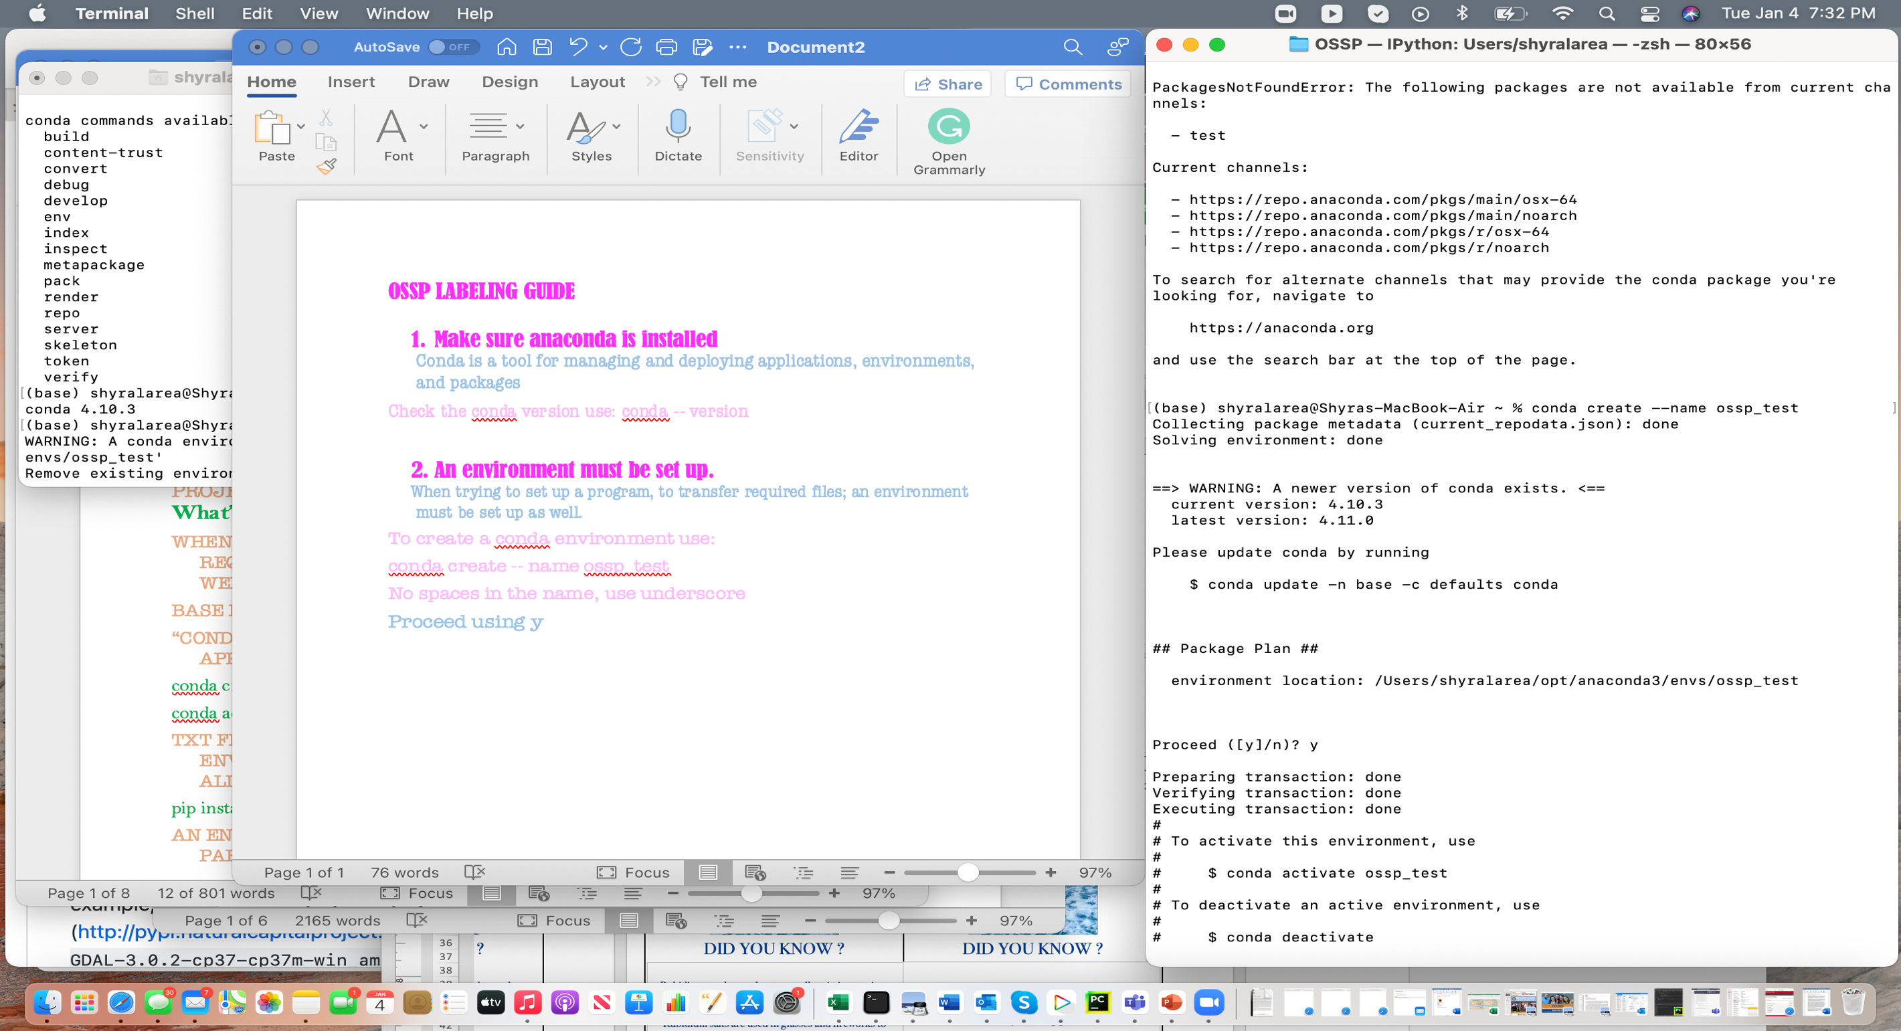

conda create -- name ossp_test

No spaces in the name, use underscore

Proceed using y

Proceed ([y]/n)? y

You must activate the environment to use it

To activate this environment, use

$ conda activate ossp_test

To deactivate an active environment, use

$ conda deactivate

1. The system requires dependencies

Commands to use are given for each package

Use y for each dependency to completely process and install required packages.

Proceed ([y]/n)? y

gdal (v2.0 or above): gdal package installation is not stable for all environments

for mac OS users: /usr/bin/ruby -e "$(curl -fsSL <https://raw.githubusercontent.com/Homebrew/install/master/install>)"

then ‘conda install -c conda-forge gdal’

For linux and windows users can go here: <https://www.lfd.uci.edu/~gohlke/pythonlibs/> and download the corresponding GDAL package to their computer

then ‘pip install <downloaded GDAL location>’

You will have to have your computer password to allow installation

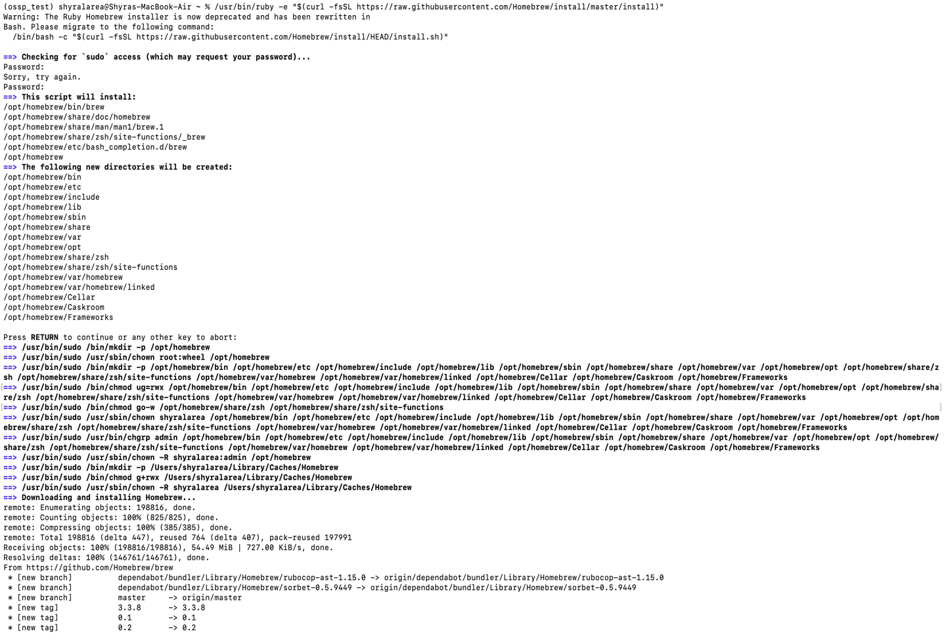

* Numpy: conda install numpy
* Scipy: conda install -c conda-forge scipy
* h5py: conda install h5py
* scikit-image: conda install scikit-image
* sklearn: conda install scikit-learn
* matplotlib: conda install matplotlib
* tkinter: conda install -c anaconda tk

1. Testing Installation
   1. Conda install ipython
   2. test all of the package downloads, use import numpy, import sklearn, etc.

* Example for GDAL given in image

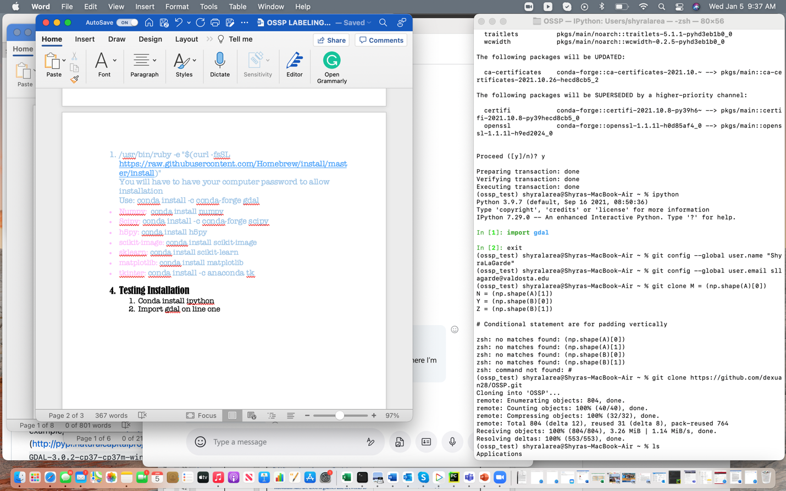

test all of the package downloads, in addition to GDAL. (just by import numpy, import sklearn) etc.

1. Configuring GitHub
2. git config --global user.name “_____”
3. git config --global user.email “_____”

use your own credentials from GitHub



clone repository to terminal system

git clone https://github.com/dexuan28/OSSP.git

1. Confirm installation:

ls command is used to list files or directories

Use “ls” command

Once inside the Training GUI:

1. Initialize your images

This makes the sea ice images visible and able to be labeled. The button is at the bottom right of the screen. 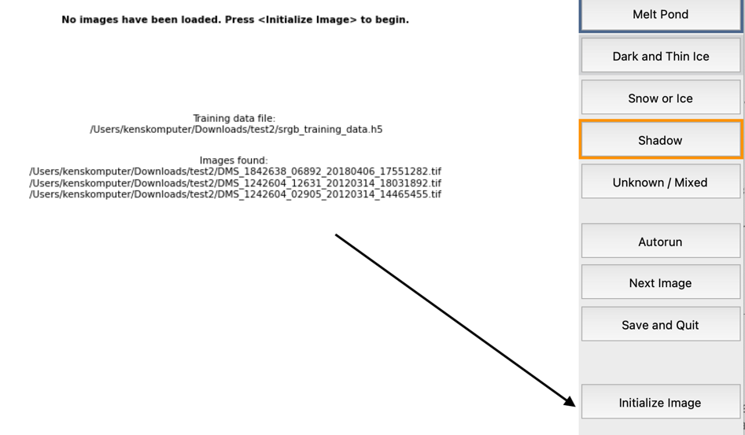

1. Labeling images

Now you will see 3 images on the left main part of the screen. The bottom left picture will have a red box ; this box shows the area of focus for the image above it. The image above will show a yellow irregular shape, this is the area that you must label properly according to the classifications.

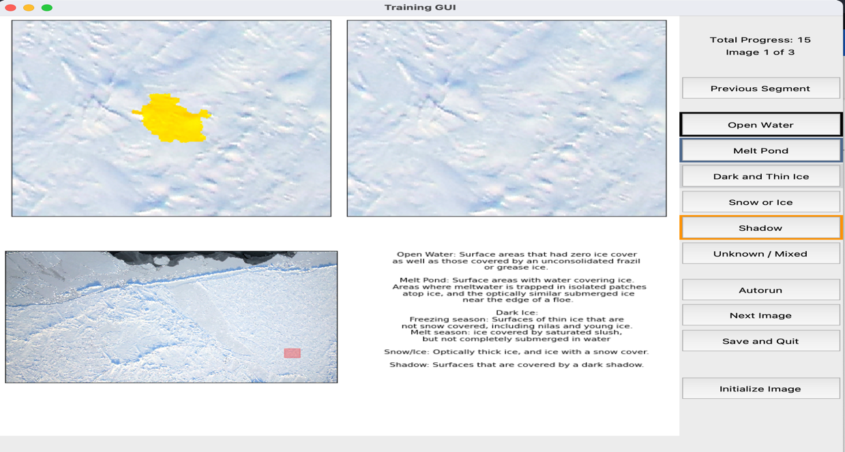

* To label you can go along with the automatic placement of the red box or you can select specific areas of the sea ice image by moving the red box. You then press the appropriate classification button located on the right side of the screen.

1. Saving your data

Once finished labeling your images how instructed, you will hit the “Save and Quit” button on the right of the screen. This with close the program and save your results.

